WEEK 3: ADVANCED DATA ANALYSIS AND VISUALIZATION IN LOGISTICS

YuvaIntern Logistics Data Analyst Internship

Prepared by: Neha

Internship Task: Week 3

Date: August 2026

1. Introduction
This report presents an advanced analysis of logistics shipment data using Python. The objective is to identify important patterns in delivery performance, transportation costs, shipment characteristics, and vehicle usage. Exploratory data analysis was performed using statistical measures such as mean, median, and mode, followed by data visualization techniques including histograms, bar charts, scatter plots, and a correlation heatmap. The analysis helps identify relationships between distance, delivery time, shipment weight, expected delivery time, and transportation cost. The findings can be used to understand operational performance and support data-driven logistics decisions.

2. Exploratory Data Analysis
The logistics dataset contains 20 shipment records and 10 variables. The numerical variables include distance, shipment weight, expected delivery time, actual delivery time, and transportation cost. The dataset contains no missing values after preprocessing. Exploratory analysis was performed to understand the central tendencies, distributions, and relationships among the numerical variables.
2.1 Central Tendency Analysis
 | Distance (km) | Weight (kg) | Expected Delivery (days) | Actual Delivery (days) | Transportation Cost (₹)
  Measure
Mean | 777.50 | 21.20 | 3.55 | 3.95 | 7145
Median | 670.00 | 19.50 | 3.50 | 3.95 | 6850
Mode | 350.00 | 10.00 | 3.00 | 3.00 | 4100

The average shipment distance was 777.5 km, while the median distance was 670 km, indicating that some longer-distance shipments increase the average. The average shipment weight was 21.2 kg. The average actual delivery time was 3.95 days compared with an expected delivery time of 3.55 days, indicating that deliveries were slightly slower than expected on average. The average transportation cost was ₹7,145, with a median of ₹6,850.
2.2 Categorical Distribution Analysis
The categorical variables were analyzed to understand the distribution of vehicle types and delivery status. The dataset contains two vehicle types: Truck and Van. Trucks were used for 12 shipments, while Vans were used for 8 shipments. Regarding delivery performance, 12 shipments were delivered on time and 8 shipments were delayed.
Category | Count
 | 12
  Truck
 | 8
  Van
 | 12
  On Time
 | 8
  On Time

The results show that trucks were the more frequently used vehicle type, accounting for 60% of the shipments. Overall, 60% of shipments were delivered on time, while 40% were delayed. This indicates that there is room for improvement in delivery performance.
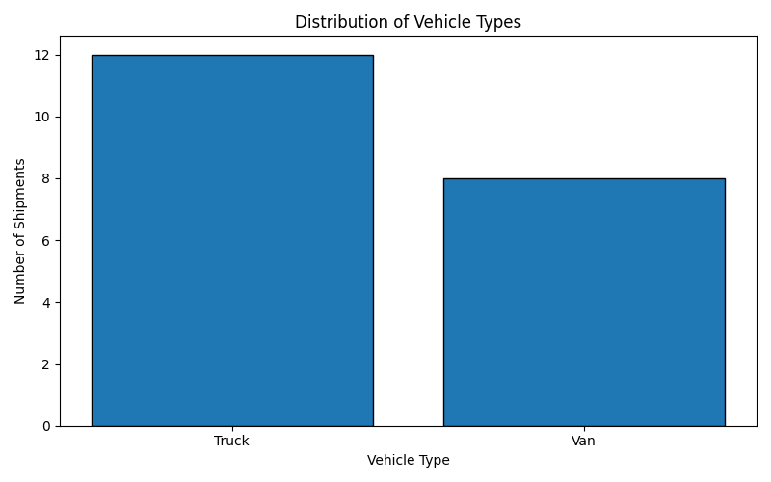

2.3 Delivery Time Distribution
The distribution of actual delivery time was examined using a histogram. The average delivery time was 3.95 days, while the median delivery time was 4 days. The values ranged from 2 to 6 days across the 20 shipments.

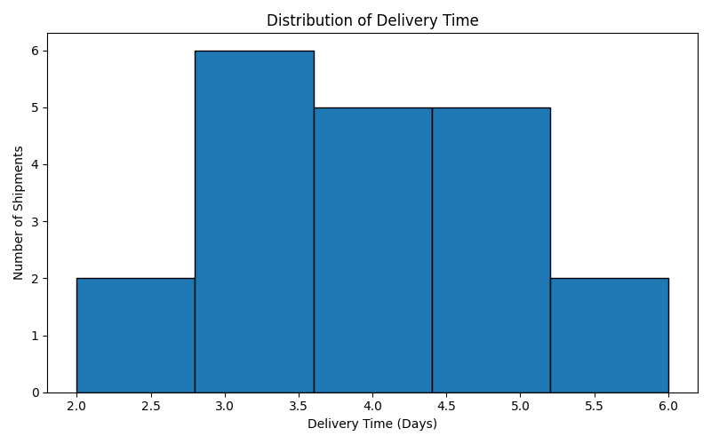
Figure 3: Distribution of Delivery Time

2.4 Transportation Cost Distribution
Transportation cost was analyzed to understand how the cost of shipping varies across different shipments. The average transportation cost was ₹7,145, while the median cost was ₹6,850. The costs varied depending on factors such as shipment distance, weight, and delivery requirements.
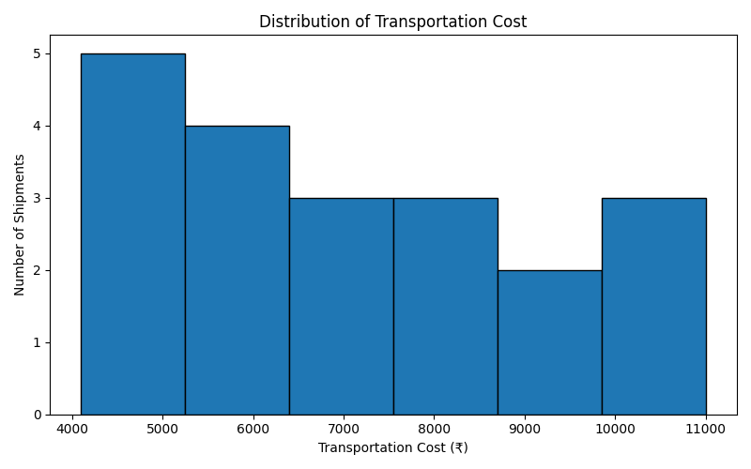
Figure 4: Distribution of Transportation Cost

2.6 Relationship Between Delivery Time and Transportation Cost
A scatter plot was used to examine the relationship between actual delivery time and transportation cost. The analysis shows that transportation cost generally increases as delivery time increases. This indicates that shipments requiring more delivery time may also involve higher transportation costs. However, other factors such as distance and shipment characteristics can also influence the total cost
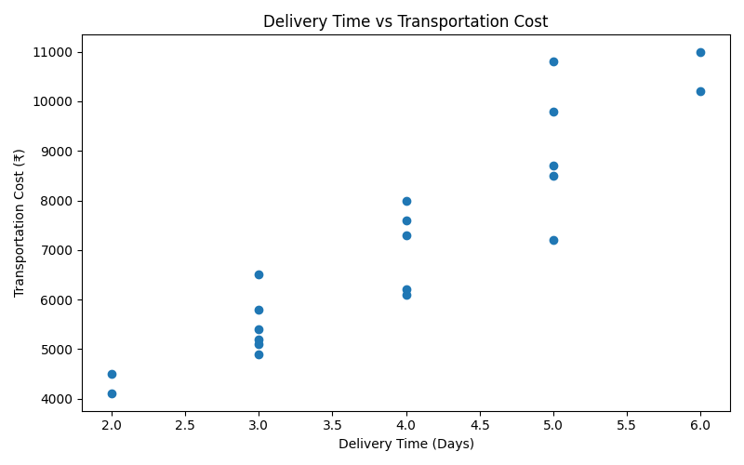
Figure 5: Delivery Time vs Transportation Cost
2.7 Relationship Between Distance and Transportation Cost
The relationship between shipment distance and transportation cost was analyzed using a scatter plot. The results show a strong positive relationship between distance and transportation cost. As the shipment distance increases, the transportation cost generally increases as well. This indicates that distance is an important factor affecting logistics transportation expenses.
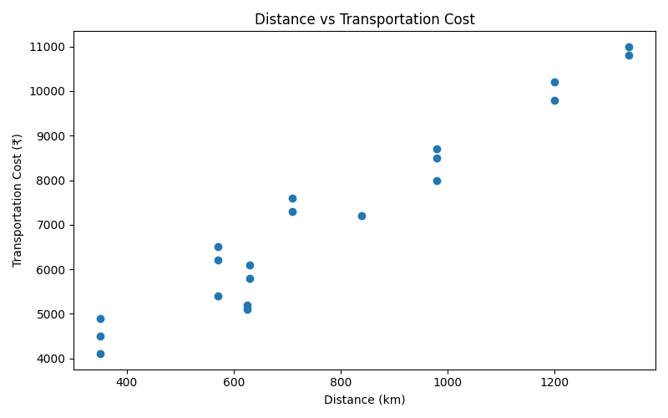
Figure 6: Distance vs Transportation Cost
2.8 Expected vs Actual Delivery Time
The expected delivery time was compared with the actual delivery time using a scatter plot. The analysis helps identify whether shipments were delivered within the expected schedule. In general, the actual delivery time tends to increase as the expected delivery time increases. Differences between expected and actual delivery times indicate that some shipments experienced delays.

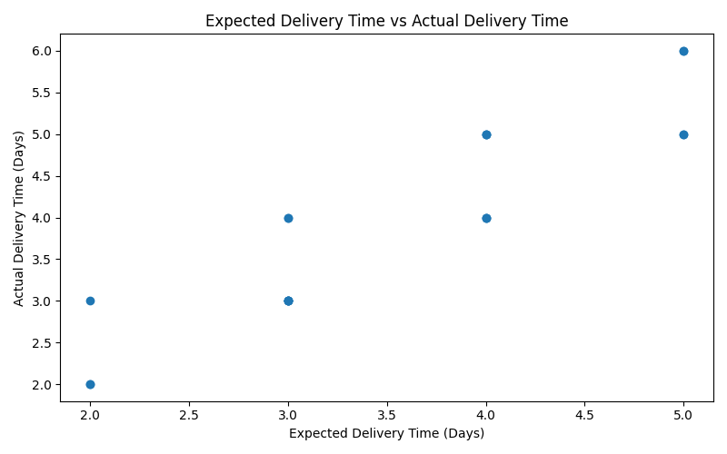
Figure 7: Expected Delivery Time vs Actual Delivery Time
2.9 Correlation Analysis
Correlation analysis was performed to understand the strength and direction of relationships between the numerical variables. The correlation matrix shows strong positive relationships between distance, expected delivery time, actual delivery time, and transportation cost. In particular, distance and transportation cost have a strong positive correlation, indicating that longer shipments generally require higher transportation costs. Expected delivery time and actual delivery time also show a strong positive relationship.
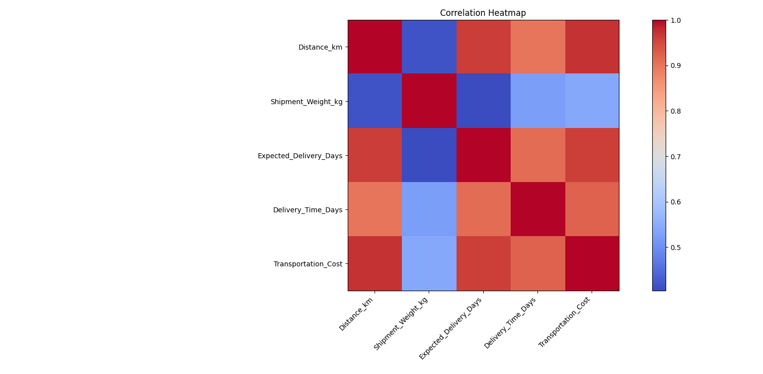
Figure 8: Correlation Heatmap of Numerical Variables
3. Key Findings
The analysis of the logistics dataset revealed several important findings related to delivery performance, transportation cost, shipment distance, and vehicle usage. The key findings obtained from the exploratory and statistical analysis are summarized below.
1. The dataset contains 20 shipment records and 10 variables.
2. 60% of shipments were delivered on time, while 40% were delayed.
3. Trucks were used for 12 shipments, while Vans were used for 8 shipments.
4. The average shipment distance was 777.5 km.
5. The average actual delivery time was 3.95 days, compared with an expected delivery time of 3.55 days.
6. The average transportation cost was ₹7,145.
7. A strong positive relationship was observed between distance and transportation cost.
8. Expected delivery time and actual delivery time also showed a strong positive relationship.
9. The correlation analysis indicates that shipment distance is an important factor associated with transportation cost.

4. Logistics Insights
The analysis provides useful insights into the operational performance of the logistics process. The results show that transportation cost is strongly associated with shipment distance, meaning that longer routes generally require higher transportation expenses. The difference between expected and actual delivery times also indicates that some shipments may require better delivery planning. The on-time delivery rate of 60% suggests that delivery performance can be monitored and improved. Vehicle usage analysis shows that trucks were used more frequently than vans in the dataset
4.1 Recommendations
- Monitor delayed shipments regularly to identify common causes of delays.
- Improve delivery scheduling by considering shipment distance and expected delivery time.
- Analyze transportation costs for longer routes to identify opportunities for cost reduction.
- Track vehicle performance to understand which vehicle types are suitable for different shipment requirements.
- Continue using data visualization and statistical analysis to monitor logistics performance
Conclusion
This project analyzed a hypothetical logistics dataset to understand shipment characteristics, delivery performance, and transportation costs. Python was used to perform exploratory data analysis, statistical analysis, and data visualization. The analysis identified important relationships between shipment distance, delivery time, and transportation cost. It also showed that 60% of shipments were delivered on time, while 40% experienced delays. Overall, the analysis demonstrates how data analysis techniques can be used to identify patterns and generate useful insights for improving logistics operations and supporting data-driven decision-making.

